Rates of Reaction Mastery Booklet
The rate of a reaction is how quickly a reaction proceeds. As a reaction proceeds, the amount of reactant will decrease and the amount of product will be increased. The amount of time this takes determines the rate of the reaction.
Part 1: Measuring the rate
The rate can therefore be measured as:
$Rate of reaction= \frac{mass of reactant lost (g)}{time (s)}$ and the unit would for the rate would be g/s
The same can be achieved by measuring the mass of the products:
$Rate of reaction= \frac{mass of product gained (g)}{time (s)}$ and the unit would for the rate would be g/s
Worked example 1:
A reaction is set up between magnesium and hydrochloric acid. After 30 seconds, the magnesium had decreased in mass by 45g. What was the rate of this reaction?
$$Rate of reaction= \frac{mass of reactant lost (g)}{time (s)}= \frac{45}{30}=1.5g/s$$
When the reaction involves a gas, the equation is the same but we measure the amount of gas in cm³ and not g. The rate is therefore given in cm³/s
Worked example 2:
A reaction is set up between magnesium and hydrochloric acid. After 30 seconds, 81cm³ of gas had been produced. What was the rate of this reaction?
$$Rate of reaction= \frac{volume of product gained ({cm}^{3})}{time (s)}= \frac{81}{30}=2.7{cm}^{3}/s$$
Mastery questions:
- In a reaction the mass of a reactant decreases by 58g in 233 seconds. What is the rate?
- In a reaction the mass of a reactant decreases by 0.43g in 80 seconds. What is the rate?
- In a reaction the mass of a product increases by 3kg in 210 seconds. What is the rate?
- In a reaction the mass of a reactant decreases by 41g in 2 seconds. What is the rate?
Maths for science:
to change g into kg you need to divide by 1000
to change kg into g you need to multiply by 1000
to change minutes into seconds you need to multiply by 60
to change hours into seconds you need to multiply by 3600

- In a reaction the 48cm³ of gas is produced in 97 seconds. Remember to check worked example 2 and calculate the rate of reaction.
- In a reaction the mass of a reactant changes from 43g at the start to 22g at the end. This takes 79 seconds. What is the rate? (hint – you can use the two masses to work out the mass of reactant lost)
- In a reaction 480g of reactant is completely used up in 1300 seconds. What is the rate?
- In a reaction the mass of a product changes by 3.1kg in 95 seconds. What is the rate?
- In a reaction the mass of a reactant changes by 0.845kg in 450 seconds. What is the rate?
- In a reaction the mass of a product changes by 21kg in 10 minutes. What is the rate? (hint – see the maths for science box to turn minutes into seconds)
- In a reaction the mass of a reactant changes by 19kg in 0.902 minutes. What is the rate?
- In a reaction, 641cm³ of gas is produced in 55 minutes. What is the rate?
- In a reaction the mass of a reactant changes by 3.1kg in 2 hours. What is the rate?
- In a reaction, the mass of reactant changes from 4.5kg to 381g in 5 hours. What is the rate?
Challenge: a reaction has a rate of 0.026g/s. This was established from measuring the mass lost from a sample of calcium carbonate across three and a half days. If the sample of calcium carbonate had a mass of 581kg at the beginning of the reaction, what was its mass at the end?

Part 2: Using graphs to measure the rate of a reaction
Often, you will not be given the mass values but will have to work them out from a graph. The graph will either be provided for you or you will have to draw it yourself.
Worked example:
The graph on the right shows how the volume of gas produced in a reaction changes with time. The reaction was conducted at two different temperatures.
Question: For the reaction conducted at 40°C, what is the rate of reaction across the first 150 seconds?
After 150 seconds on the graph, 40cm³ of gas had been produced:

$$Rate of reaction= \frac{volume of product gained ({cm}^{3})}{time (s)}= \frac{40}{150}=0.27{cm}^{3}/s$$
Mastery questions:
- For the reaction above conducted at 40°C, what is the rate of reaction across the first 50 seconds?
- For the reaction above conducted at 40°C, what is the rate of reaction across the first 10 seconds?
- For the reaction above conducted at 40°C, what is the rate of reaction across the first 300 seconds?
- For the reaction above conducted at 20°C, what is the rate of reaction across the first 50 seconds?
- For the reaction above conducted at 20°C, what is the rate of reaction across the first 80 seconds?
- For the reaction above conducted at 20°C, what is the rate of reaction across the first 20 seconds?
- For the two reactions above, what is the difference in rates across the first minute?
- For the two reactions above, what is the difference in rates across 200 seconds?
- An experiment was conducted to see how the mass of magnesium changes with time after it has been placed in acid. The graph to the left was plotted. Draw a line of best fit to complete the graph.
- One result is anomalous. This means it does not fit the pattern shown by the other results. Which result is the anomalous one?
- What is the rate of reaction across the first five minutes? (hint – this is similar to question 15-20. Look at the mass at 0 minutes and the mass at 5 minutes to calculate the change in mass)
- What is the rate of reaction across ten minutes?
- What is the rate of reaction:
  - Across the last five minutes?
  - Across the last three minutes?
  - Across the first 450 seconds?
  - Between the second and eighth minute?
  - Between the second and third minute?
  - What is the difference in the rate of reaction between the first and last minute of the reaction?

Part 3: Using graphs to measure the rate of a reaction at a specific time by drawing a tangent
The gradient of a line is how steep it is. The graphs above show curved lines, which means that the gradient (steepness) is different at different times. In both graphs, the gradient is steepest at the start of the reaction.
Drawing a tangent to the curve at a specific point means we can see what the rate is at that point. If the tangent is steep, the rate is large..
Worked example:
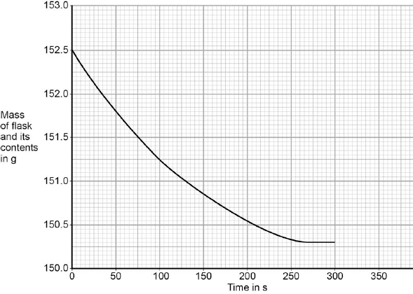
The graph on the right shows the change in mass of a reactant with time. As a class, we will draw tangents to this graph at different points and look at the rate.

Part 4: How the rate is measured in the lab
There are three main ways to measure the rate of a reaction:
- Conduct the experiment on a balance. This enables you to watch the mass changing as the reaction proceeds. Only suitable for reactions where a gas is produced – the gas escapes the vessel and the mass decreases.
- Collect gas in a syringe or cylinder. You can use a stopwatch to see how much gas is produced with time. Only suitable for reactions where a gas is produced.
- The “Disappearing Cross” method is where you start with clear reactants which become cloudy as the reaction goes on. This occurs because the reaction produces a solid (precipitate). You can time how long it takes for a cross underneath the reaction vessel (the flask) to become completely blocked by the precipitate. Only suitable for reactions which start with solutions and produce a solid.

Mastery questions:
For each of the reactions below, state which methods would be most suitable. For some of them you will have to work out what the products are from previous topics. You will also need to balance the equations.
- Mg(s) + HCl(aq) MgCl₂(aq) + H₂(g)
- Na₂S₂O₃(aq)+ HCl(aq) NaCl(aq) + H₂O(l) + SO₂(g) + S(s)
- PbNO₃(aq) + KI(aq) KNO₃(aq) + PbI(s)
- When calcium carbonate is added to sulphuric acid, what are the products?
Part 5: Collision Theory
In order for a chemical reaction to take place, the atoms or molecules involved need to collide with each other. However, they also need to collide with enough energy before a reaction will take place. If they don’t have enough energy they will just bump off each other. We call this amount of energy the activation energy.
In order to increase the rate of reaction, you must therefore either
- Increase the frequency of collisions
- Increase the energy that reactants have when they collide
These are the variables which can be changed to increase the rate of reaction:
- Surface area
- Concentration (for solutions)
- Pressure (for gases)
- Temperature
- Catalyst
Part 5.1: The effect of surface area on the rate of reaction
By increasing the surface area of a substance, you are increasing the number of particles available to react
In this diagram, a lump of metal is being reacted with a solution. In the first image, only the particles at the very edge of the metal can collide with particles from solution. Particles from inside the metal cannot collide.
In the second image, particles from the inside are now on the edges of the material and are free to collide with the solution. This results in more frequent collisions and a greater rate of reaction. In order to increase the surface area of a solid, it can be crushed up into smaller pieces.
Worked examples (past GCSE questions)
Example 1:
A student investigated the rate of reaction between calcium carbonate (marble chips) and hydrochloric acid.
Explain, in terms of particles and collisions, the effect that increasing the surface area of the marble chips has on the rate of reaction (3).
The rate of reaction is increased. This is because more particles are available to collide , resulting in more frequent collisions.
Teacher’s notes: this answer correctly references the most important ideas of particles colliding more frequently. Students often write “more collisions” but the important part is that they are more frequent, meaning that there are more collisions in the same amount of time. Students also often forget to actually state the effect (the rate increases) so this answer avoids that problem.
Example 2:

Dilute hydrochloric acid reacts with sodium carbonate. The word equation for this reaction is:

sodium carbonate + hydrochloric acid → sodium chloride + water + carbon dioxide

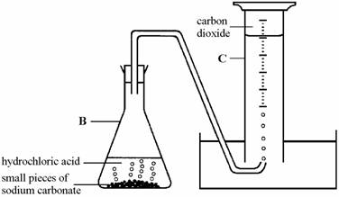
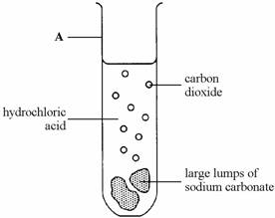
(a) The diagram on the left shows apparatus used by student X to investigate this reaction. The diagram on the right shows the apparatus used by student Y.

(ii) Both students X and Y used the same volume of acid, concentration of acid, temperature, mass of sodium carbonate. Use information from the diagrams to explain why the reaction that student Y carried out was faster. (3)

Student Y’s reaction was faster because the pieces of sodium carbonate were smaller. This meant there were more collisions and a greater rate of reaction.

Teacher’s notes: the student has correctly identified that there was a greater rate of reaction in Y than X. However, they just wrote that there were more collisions, not more frequent collisions. They also did not specifically mention that the smaller pieces of sodium carbonate meant a greater surface area
Mastery questions:
- A number of questions related to surface area have been provided, as well as suggested answers. Assess each one to see if it contains all the most important information.
  - Explain why the acid in your stomach is more effective at digesting food if the food has been chewed.
Chewing food into smaller pieces gives it a larger surface area. This results in a greater rate of reaction
  - A student leaves an iron nail and some iron wool out in the air. Which will rust quicker?
The iron nail is made of smaller bits so will have a greater rate of reaction.
  - A student wishes to investigate the rate of reaction of marble chips with acid and different temperatures. Explain why the student must use the same sized chips for both experiments.
Different sized chips will have different rates of reactions due to more collisions.
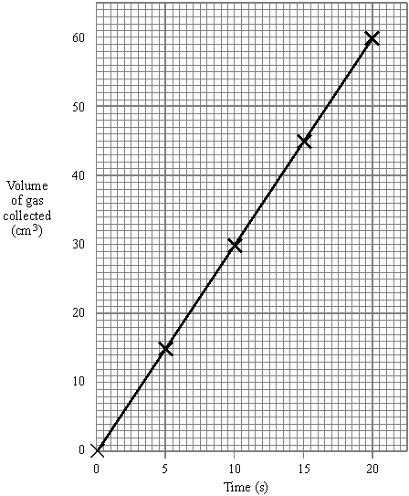
- The graph to the left shows the amount of gas produced when medium sized chips of calcium carbonate are added to acid. Draw a line to predict how much gas would be produced for:
  - Small chips of calcium carbonate
  - Large chips of calcium carbonate
  - Explain your answers.
- Calculate the mean rate of reaction between 10 and 20 seconds.
- Calculate the mean rate of reaction between 0 and 10 seconds.

- The graph below shows the amount of gas produced when large lumps of iron are added to acid with minutes being on the x axis.
  - Calculate the mean rate of reaction across the first 8 minutes.
  - Draw a tangent to the line at 6 minutes and at 4 minutes.
  - Is the rate greater at 6 minutes or 4 minutes?
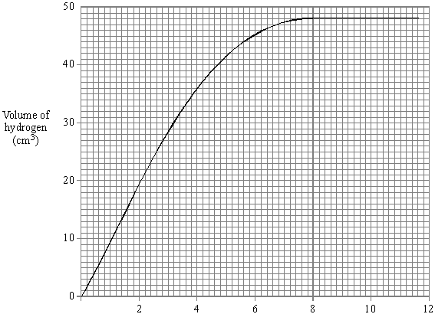
  - Draw a line to predict how much gas is produced from a reaction involving the same mass of iron but used as a powder. Explain your answer.

Part 5.2: The effect of concentration on the rate of reaction
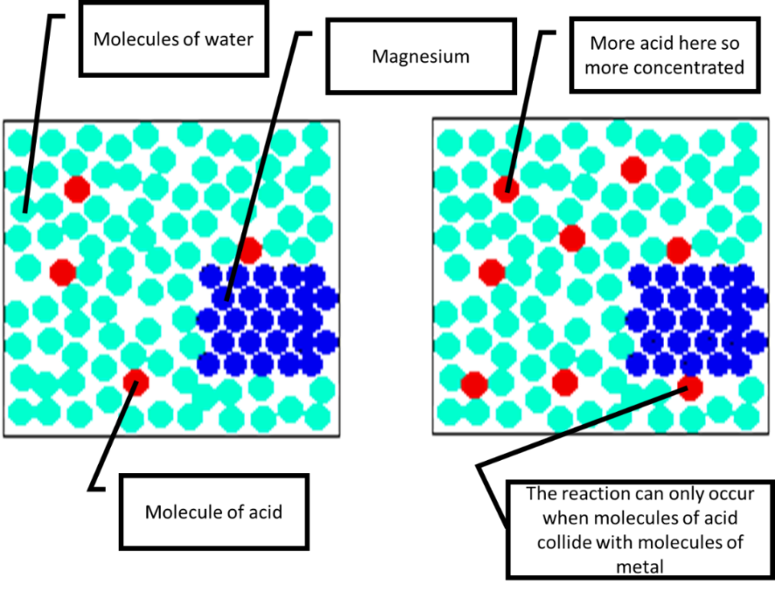
When a reaction involves a solution (like an acid), the greater the concentration, the greater the number of particles. So a concentrated acid has more acid particles in it than not. More particles mean more frequent collisions, so a greater concentration increases the rate of reaction. The diagram below on the left shows a less concentrated acid, and the one on the right shows a more concentrated acid.
Remember also that if you are increasing the concentration, you are also increasing the amount of reactant which will also increase the amount of product.

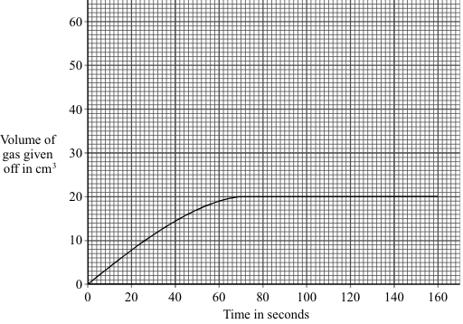
Worked Example (past GCSE question)

The graph shows the volume of gas given off during an experiment using hydrogen peroxide solution and manganese oxide.

Draw on the graph to show the result you would expect if the volume of hydrogen peroxide solution had been the same, but it was twice as concentrated. (Total 3 marks)

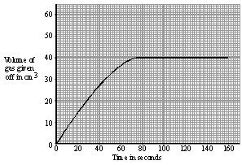
The line would have to be steeper as the rate of reaction would be increased. But it would also have to go higher. If you generated 20cm³ of gas in the first experiment, you would expect double that if you double the concentration. The second line would therefore go up to 40cm³:

Mastery Questions:
- A student investigates the reaction between magnesium and hydrochloric acid.
  - Write a word and symbol equation for this reaction.
  - What ions does hydrochloric acid release?
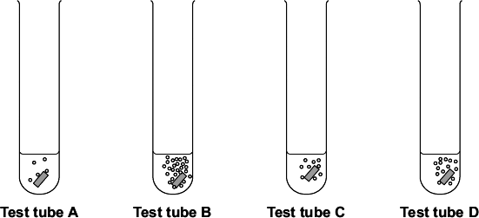
  - The student investigated how changing the concentration of the hydrochloric acid affects this reaction. Each test tube below contained a different concentration of hydrochloric acid. The diagrams show the results of this experiment.
    - Which test tube had the most concentrated acid?
    - How can you tell from the diagram?
    - Which test tube had the least concentrated acid?
    - Once the reaction in each test tube had finished, which one will have produced the most gas?
    - Suggest one control variable for this experiment.
    - State the effect of increasing the concentration on the rate of reaction.
    - Explain your answer to vi.
Part 5.3: The effect of pressure on the rate of reaction
Low pressure
High pressure
When reactions involve a gas as a reactant, increasing the pressure means you have moved the gas particles closer to each other by reducing the space available to them.
When a reaction is conducted under high pressure, there are more frequent collisions as the particles are closer together. This results in a greater rate of reaction.

Worked Example:
Methane reacts with steam as below:
CH₄(g) + H₂O(g) CO(g) + H₂(g)
State and explain the effect of increasing the pressure on the rate of the reaction (3 marks)
Increasing the pressure will increase the rate of the reaction. This is because the molecules of gas will be closer together, resulting in more frequent collisions.
- Methane (formula above) reacts with oxygen (O₂) to produce carbon dioxide (CO₂) and steam (H₂O). Write a balanced symbol equation for this reaction.
- The reaction becomes very hot. Is this reaction endo or exothermic?
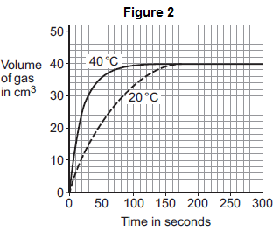
- The pressure under which the reaction is conducted is decreased. State the effect this has on the rate of reaction.
- Explain your answer to Q49.
Part 5.4: The effect of temperature on the rate of reaction
Increasing the temperature increases the rate of reaction. This is for two separate reasons. It is important that you do not confuse these reasons – this is a common student error.
- Increasing the temperature makes the particles move faster
  - This results in more frequent collisions
- Increasing the temperature means that more particles have the activation energy
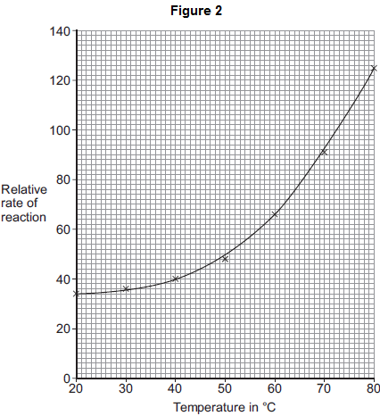
  - This means that more collisions result in a reaction
Worked example
The graph below shows the amount of gas produced in a reaction which was conducted at two different temperatures.
Explain, in terms of particles and collisions, the effect of increasing the temperature on the rate of reaction. Use data from the graph to support your answer. (6 marks)
The graph shows that as the temperature increases, the gas is produced quicker. This can be proved at 50 seconds, where the 20°C reaction had produced 22cm³, but the 40°C reaction had produced 36cm³.
This proves that as temperature is increased, the rate of reaction increases.
This is because as the temperature is increased, the particles move faster and collide more frequently.
Also, a higher temperature means that more particles have the activation energy so more collisions result in a reaction.
Mastery Questions
The graph above shows the rate of reaction at a number of different temperatures for a reaction between marble and acid.
- Describe how the rate of reaction changes as the temperature is increased.
- Explain this effect.
- State three variables that would need to be controlled for this reaction.
- State and explain the effect of using the same mass of marble but larger pieces on the rate of reaction.
- The experiment was repeated with acid that was twice as concentrated. State two differences you would expect in the results.
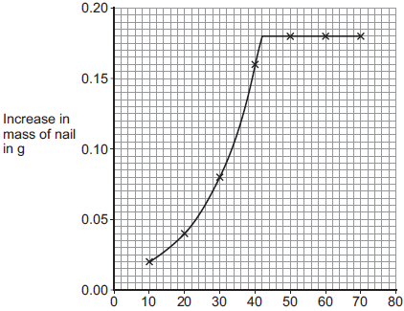
- A student investigate the change in mass of a nail that was sealed in a box with air and water.
Temperature (°C)
- The experiment was conducted at a number of different temperatures. The results are shown in the graph to the right. Use the graph to describe the relationship between the temperature and the increase in mass of the nail.
- The student increased the pressure inside the box. How would this affect the rate of reaction?
- Explain your answer.
- The nail was cut up into smaller pieces. How would this affect the rate of reaction?
- Explain your answer.

Part 6: Catalysts
A catalyst is something which is added to a reaction to increase its rate. It is not used up as part of the reaction. It works by lowering the activation energy of the reaction, so when particles with less energy collide a reaction can still occur.
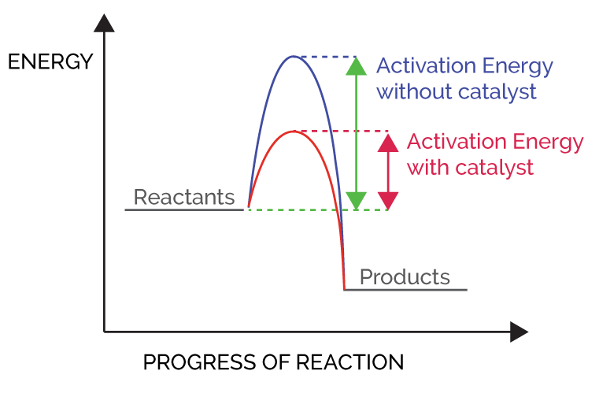
Worked Example
A reaction is conducted between magnesium and oxygen. At the end of the reaction, the mass of the magnesium had increased by 14g. This took 4 minutes. The reaction was repeated again, but a catalyst had been added to the reaction. It took 3 minutes for the magnesium to increase by 14g. Explain this observation.
Catalysts increase the rate of a reaction by lowering the activation energy required for the reaction to take place.
Mastery Questions:
- For the reaction above, calculate the rate of reaction in both cases.
- The catalyst initially had a mass of 5.5g. At the end of the reaction it was re-weighed and had a mass of 5.5g. Explain this result.
- Hydrogen peroxide decomposes into water and oxygen gas in the presence of a catalyst. The formula for hydrogen peroxide is H₂O₂(aq). Write a word and balanced symbol equation for this reaction.
- Draw a covalent bonding diagram for water (hint – use your notes or page 44 to help).
- Draw a covalent bonding diagram for oxygen.
- Explain the effect of a catalyst on the rate of reaction.
- The diagram below shows the shapes of different catalysts
A B
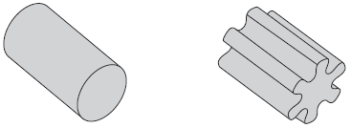
Suggest and explain why shape B is more effective as a catalyst than shape A.

Part 7: How the rate changes with time
You may have noticed that in all the graphs we have seen so far, the curve always starts off very steep, then becomes less steep and then completely flat. This is because at the beginning of a reaction the rate is very high, but as the reaction goes on the rate decreases until it is zero; this is when the reaction has finished.
This is because as a reaction proceeds, the reactant particles collide with each other and turn into product. As time goes on, there is less and less reactant and more and more product. If there is less reactant it makes collisions between reactants less likely, reducing the rate of the reaction. By the end of the reaction there are no reactants left, only products. At this point the reaction has completed and the rate is zero.

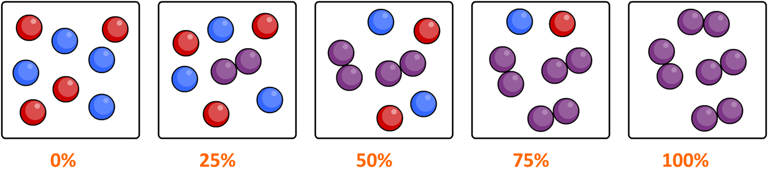
Mastery exercise:
In your exercise book, outline a method to investigate the rate of reaction for marble chips added to acid. The reaction produces carbon dioxide gas.
- Draw a sketch graph to predict the results
- Describe the shape of your graph fully
- Explain how you could use the graph to establish the mean rate of reaction
- Describe and explain how the rate changes with time
- State and explain the effect of increasing the temperature on the reaction
- State and explain the effect of increasing the concentration of the acid used
- State and explain the effect of crushing the marble chips
- State and explain the effect of using a catalyst

