Day 1 | Explain what MRSA is and how it is spread.
Day 2 | List 3 examples of a virus.
Day 3 | Define pathogen
Day 4 | Draw and label a plant and animal cell.
Day 5 | Draw a cartoon explaining how a vaccination works.
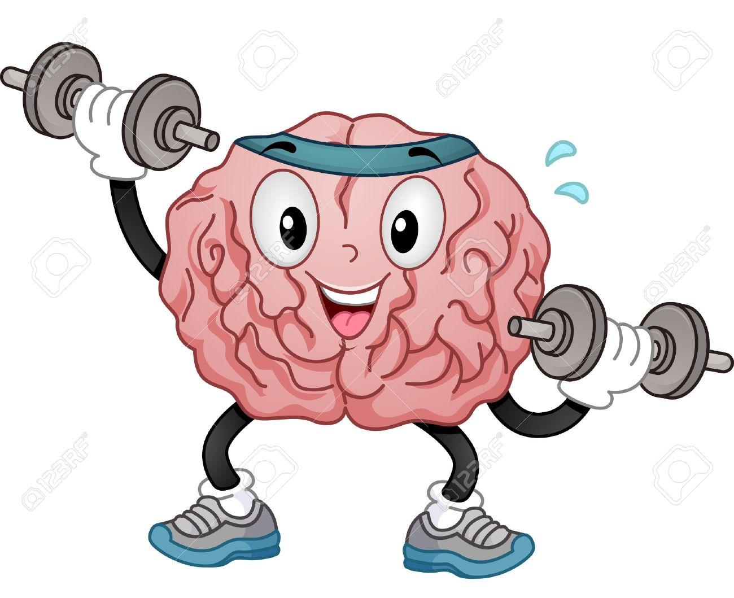
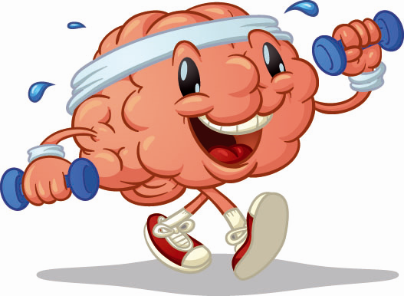
Train your Brain
Dedicate 10-15 minutes every day to complete these tasks.
It allows you to track your revision gradually to get you to your exams feeling well prepared.
My brain is like a muscle. When I exercise it, it gets stronger.
2

