Q1.
(a) A particle of ammonia is represented by the formula NH₃ or as:
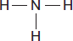
(i) How many different elements are there in a particle of ammonia?
_______________________________
(1)
(ii) Draw a ring around the correct answer to complete the sentence.

A particle of ammonia is called | an atom.  an ion.  a molecule.
(1)
(iii) Complete the dot and cross bonding diagram for ammonia.
Show only electrons in the outer energy level of each atom.
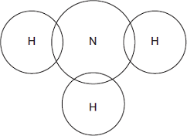
(2)
(b) Ammonia gas reacts with hydrogen chloride gas to produce a white solid.
The formula of the white solid is NH₄Cl
(i) Complete the equation by adding the correct state symbols.
NH₃(g) + HCl(____) NH₄Cl(____)
(1)
(ii) The white solid has the formula NH₄Cl
Complete the name of the white solid.
Ammonium _______________________________
(1)
(c) Concentrated ammonia solution gives off ammonia gas.
Concentrated hydrochloric acid gives off hydrogen chloride gas.
Apparatus was set up as shown in Diagram 1.
Diagram 1

Cotton wool soaked  in concentrated  hydrochloric acid |  | Cotton wool soaked  in concentrated  ammonia solution
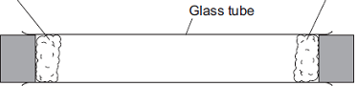
(i) Concentrated hydrochloric acid is corrosive.
Give one safety precaution you should take when using concentrated hydrochloric acid.
______________________________________________________________
______________________________________________________________
(1)
(ii) After 3 minutes a white solid was seen in the glass tube, as shown in Diagram 2.
Diagram 2

Cotton wool soaked  in concentrated  hydrochloric acid |  | Cotton wool soaked  in concentrated  ammonia solution
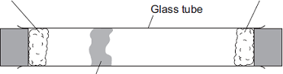
White solid formed here
Suggest why the white solid is seen nearer the concentrated hydrochloric acid than the concentrated ammonia.
______________________________________________________________
______________________________________________________________
(1)
(iii) The experiment was repeated at a higher temperature.
Explain why the white solid was produced in less than 3 minutes.
______________________________________________________________
______________________________________________________________
______________________________________________________________
______________________________________________________________
(2)
(Total 10 marks)
Q2.
This question is about calcium.
(a) What type of compound is calcium oxide?
Tick one box.

An acid
A base
A carbonate
A salt
(1)
(b) Ionic compounds, such as calcium oxide, have high melting points.
Complete the sentences. Use words from the box.

bonds forces ions layers
Calcium oxide has a giant ionic lattice in which there are strong electrostatic
______________________ of attraction in all directions.
(1)
(c) The figure below shows the electronic structure of an oxygen atom and a calcium atom.
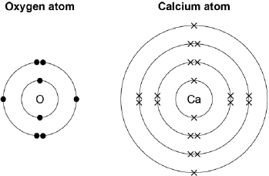
Describe how the calcium atom and the oxygen atom forms calcium oxide.
You should give the charge on each ion formed.
___________________________________________________________________
___________________________________________________________________
___________________________________________________________________
___________________________________________________________________
___________________________________________________________________
___________________________________________________________________
___________________________________________________________________
___________________________________________________________________
(4)
(Total 6 marks)
Q3.
This question is about sodium chloride and iodine.
(a) Describe the structure and bonding in sodium chloride.
___________________________________________________________________
___________________________________________________________________
___________________________________________________________________
___________________________________________________________________
___________________________________________________________________
___________________________________________________________________
___________________________________________________________________
___________________________________________________________________
(4)
(b) When sodium chloride solution is electrolysed, one product is chlorine.
Name the two other products from the electrolysis of sodium chloride solution.
___________________________________________________________________
___________________________________________________________________
(2)
(c) Many people do not have enough iodine in their diet.
Sodium chloride is added to many types of food. Some scientists recommend that sodium chloride should have a compound of iodine added.
Give one ethical reason why a compound of iodine should not be added to sodium chloride used in food.
___________________________________________________________________
___________________________________________________________________
(1)
(d) The bonding in iodine is similar to the bonding in chlorine.
(i) Complete the diagram below to show the bonding in iodine.
Show the outer electrons only.
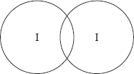
(2)
(ii) Explain why iodine has a low melting point.
______________________________________________________________
______________________________________________________________
______________________________________________________________
______________________________________________________________
______________________________________________________________
______________________________________________________________
(3)
(iii) Explain, in terms of particles, why liquid iodine does not conduct electricity.
______________________________________________________________
______________________________________________________________
______________________________________________________________
______________________________________________________________
(2)
(Total 14 marks)
Q4.
Carbon atoms are used to make nanotubes.
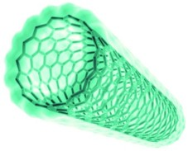
© Denis Nikolenko/Hemera/Thinkstock
Carbon atoms in a nanotube are bonded like a single layer of graphite.
The figure below shows the structure of a single layer of graphite.
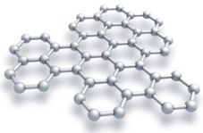
© Evgeny Sergeev/iStock/Thinkstock
(a) Suggest why carbon nanotubes are used as lubricants.
___________________________________________________________________
___________________________________________________________________
___________________________________________________________________
___________________________________________________________________
(2)
(b) Explain why graphite can conduct electricity.
___________________________________________________________________
___________________________________________________________________
___________________________________________________________________
___________________________________________________________________
(2)
(Total 4 marks)

Mark schemes
Q1.
(a) (i) two
1
(ii) a molecule
1
(iii) one pair of electrons between nitrogen and each of 3 hydrogens
1
rest correct
second mark dependent on first
1
(b) (i) (g) (s)
1
(ii) chloride
ignore formulae
1
(c) (i) any one from:
• wear goggles
• wear gloves
• do not breathe in fumes
• wipe up spills immediately
• work in a fume cupboard
1
(ii) (particles of) ammonia move faster than (particles of) hydrogen chloride
allow diffuses faster
allow hydrochloric acid
1
(iii) particles / molecules have more energy
do not accept atoms / ions
1
so they move faster
ignore references to rate of reaction
1
[10]
Q2.
(a) A base
1
(b) forces
1
(c) calcium loses electrons and oxygen gains electrons
max 3 for incorrect reference to atom / ion or to oxygen / oxide
1
two electrons are transferred
1
calcium has a 2⁺ charge
1
oxide has a 2– charge
1
[6]
Q3.
(a) lattice / giant structure
max 3 if incorrect structure or bonding or particles
1
ionic or (contains) ions
1
Na⁺ and Cl⁻
accept in words or dot and cross diagram: must include type and magnitude of charge for each ion
1
electrostatic attraction
allow attraction between opposite charges
1
(b) hydrogen
allow H₂
1
sodium hydroxide
allow NaOH
1
(c) any one from, eg:
• people should have the right to choose
• insufficient evidence of effect on individuals
• individuals may need different amounts.
allow too much could be harmful
ignore religious reasons
ignore cost
ignore reference to allergies
1
(d) (i) one bonding pair of electrons
accept dot, cross or e or − or any combination, eg
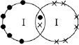
1
6 unbonded electrons on each atom
1
(ii) simple molecules
max 2 if incorrect structure or bonding or particles
accept small molecules
accept simple / small molecular structure
1
with intermolecular forces
accept forces between molecules
must be no contradictory particles
1
which are weak or which require little energy to overcome − must be linked to second marking point
reference to weak covalent bonds negates second and third marking points
1
(iii) iodine has no delocalised / free / mobile electrons or ions
1
so cannot carry charge
if no mark awarded iodine molecules have no charge gains 1 mark
1
[14]
Q4.
(a) nanotubes can slide (over each other)
allow nanotubes can roll (over each other)
1
because no (covalent) bonds between the nanotubes
accept weak forces between the nanotubes or weak intermolecular forces
allow layers for nanotubes throughout
1
(b) delocalised electrons
accept free electrons
1
so (delocalised) electrons can move through the graphite
accept so (delocalised) electrons can carry charge through the graphite
1
[4]

