B3 Organisation and the digestive system SLOP
Spec points 4.2.1 – 4.2.2.1
B3.1 Tissues and organs
- Rearrange the following parts of the body in the correct organisation levels: (1)
Tissue Organ system Cell Organism Organ
- Define ‘tissue’. (2)
- Define ‘organ’. (2)
- The stomach contains mainly three types of tissues. State their functions. (3)
a.) Muscular tissue
b.) Glandular tissue
c.) Epithelia tissue
- Decide for each of the following if they are a specialised cell, tissue or organ. Explain and state their functions. (6)
a.) Pancreas
b.) Neurone
c.) Kidney
- Give three examples of organ systems in the body. For each of them, list three organs involved in that system. (9)

B3.2 The human digestive system
- What is digestion? (1)
- Why is digestion important to us? (1)
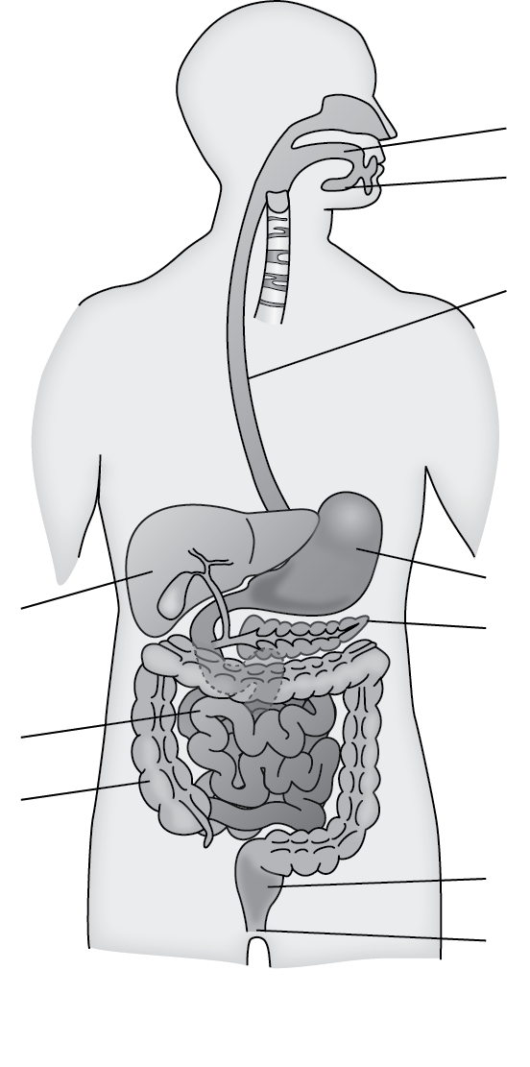
- Label the digestive system. (11)
- On the labelled diagram above, annotate each organ with their functions. (11)
- Explain why the digestive system is an organ system. (2)
- Describe and explain the adaptations of the small intestine to help with nutrient absorption. (4)
- State the functional difference between the small and large intestines. (2)
- How is the liver important in helping digestion? (2)

B3.3 The chemistry of food
Carbohydrates
- Give two functions of carbohydrates. (2)
- Which atoms make up carbohydrates? (1)
- State the monomer (the basic unit) of carbohydrates. (1)
- State the chemical formula of glucose. (1)
- Give two examples of complex carbohydrates. (2)
- What types of food contain lots of carbohydrates? Give three examples. (3)
- Describe a test for starch. (2)
- Describe how you would carry out a test for sugars. (4)
Lipids
- What are the two types of lipids? (2)
- Which atoms make up lipids? (1)
- State two functions of lipids. (2)
- Draw a labelled diagram to illustrate the structure of a lipid molecule. (2)
- What types of food contain lots of lipids? Give two examples. (2)
- Describe how you would carry out a test for lipids. (3)
Proteins
- Give two functions of proteins. (2)
- Which atoms make up proteins? (1)
- What makes up proteins? (1)
- Describe how different proteins can be made. (3)
- Describe how you would carry out a test for proteins. (2)
Summary task
Draw a summary table, including a description, uses in living organisms and sources in our diet for all three types of biological molecules.

B3.4 Catalysts and enzymes
- What are enzymes? (2)
- What is the active site of an enzyme? (1)
- Match the following keywords with their functions.
Catalyst | The enzyme and substrate bound together.
Enzyme | The special site in the structure of an enzyme where the substrate binds.
Enzyme-substrate complex | The energy needed for a chemical reaction to take place.
Activation energy | A substance which changes the rate of a chemical reaction without being changed itself.
Active site | A biological catalyst.

- Draw a labelled diagram to illustrate the lock-and-key model of enzyme mechanism.
- Define ‘metabolism’. (1)
- Describe the three types of metabolic reactions. Give one example for each of them. (6)

B3.5 Factors affecting enzyme action
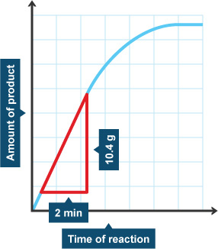
- What does denaturation mean? (2)
- What happens to enzymes when the temperature is: (2)
a.) Too low
b.) Too high
- Draw an annotated graph to illustrate the effects of temperature on enzyme RoR. (5)
- Explain the effects of temperature on enzyme action. (5)
- What is the optimum temperature for enzymes in the human body? (1)
- How does a change in pH cause enzymes to denature? (3)
- Using the graph given, calculate the rate of reaction of the enzyme. Remember to include units. (2)

B3.6 How the digestive system works
- Name the types of enzymes that catalyse the breakdown of: (3)
a.) Carbohydrates
b.) Lipids
c.) Proteins
- Which organs in the digestive system produce digestive enzymes?
- Complete the following table. There may be more than one answer needed in some boxes. (17)
Enzymes | Substrate | Products | Produced in… | Works in…
 | Starch
 | Proteins
 | Lipids

- What is pepsin? (1)
- What is the difference between pepsin and pancreatic amylase? (2)
- What is the difference between pepsin and proteases produced by the pancreas? (2)
- Draw a graph to illustrate how pH affects the actions of pepsin and lipase. (4)
- Describe how to carry out an investigation to find the optimum pH for amylase. (6)

B3.7 Making digestion efficient
- What are the functions of hydrochloric acid in the stomach? (2)
- How is the stomach adapted to protect itself from pepsin and the hydrochloric acid? (1)
- Following from Q2, what disease may develop if the stomach loses such adaptation? (1)
- Suggest the optimum pH for enzymes to work in the small intestine. (1)
- Which organ produces bile? (1)
- Where is the bile stored before it is mixed with the food from the stomach? (1)
- Describe and explain the functions of bile. (4)
- Why is emulsification important to lipid digestion? (3)
- Is it correct to say “the stomach produces hydrochloric acid to digest food”? Why/Why not? (2)
- Is it correct to say “bile breaks down lipids to glycerol and fatty acids”? Why/Why not? (3)

