Q1.
This question is about structure and bonding.
(a) Figure 1 shows part of one layer of graphene.
Figure 1
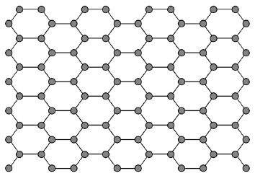
Which element is graphene made from?
Tick one box.

Carbon
Copper
Hydrogen
Sodium
(1)
(b) Each atom in graphene has one delocalised electron.
Complete the sentence.
Choose the answer from the box.

act as a lubricant | be used as a fuel
conduct electricity | dissolve in water
Delocalised electrons allow graphene to __________________________ .
(1)
(c) Which structure is a fullerene?
Tick one box.

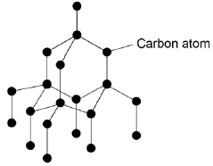
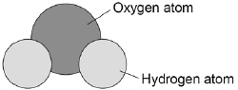
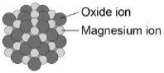
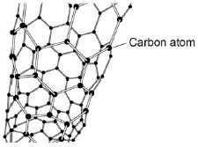
(1)
Figure 2 shows part of a large hydrocarbon molecule.
Figure 2
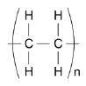
(d) Which two elements are in all hydrocarbons?
1. _________________________________________________________________
2. _________________________________________________________________
(2)
(e) Complete the sentence.
Choose the answer from the box.

an atom | a metal | a polymer | a salt
The large molecule represented in Figure 2 is __________________________ .
(1)
(f) Complete the sentence.
Choose the answer from the box.

attract | bond | slide | vibrate
Metals can be stretched into wires
because the layers of atoms can __________________________ .
(1)
(Total 7 marks)
Q2.
This question is about electrolysis.
(a) How many different elements are in the formula AgNO₃?
Tick one box.

2 |  | 3 |  | 5 |  | 6
(1)
(b) How many atoms are in the formula AgNO₃?
Tick one box.

2 |  | 3 |  | 5 |  | 6
(1)
An electric current is passed through silver nitrate solution.
Figure 1 shows the apparatus.
Figure 1
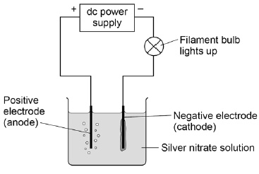
The solution contains four ions:
• Ag⁺
• H⁺
• NO₃–
• OH–
(c) Where do the H⁺ and OH– ions come from?
Tick one box.

Air
Electrodes
Silver nitrate
Water
(1)
(d) Ag⁺ ions and H⁺ ions are attracted to the negative electrode (cathode).
Give a reason why.
___________________________________________________________________
___________________________________________________________________
(1)
(e) Silver is produced at the negative electrode (cathode) and not hydrogen.
What does this tell you about the reactivity of silver?
Tick one box.

Silver is less reactive than hydrogen
Silver is less reactive than oxygen
Silver is more reactive than nitrate
Silver is more reactive than water
(1)
(f) The hydroxide ion (OH–) is attracted to the positive electrode (anode).
The equation shows what happens at the positive electrode (anode).
4OH– → 2H₂O + O₂ + 4e–
Name the gas produced at the positive electrode (anode).
___________________________________________________________________
(1)
(g) An electric current is passed through sodium chloride solution.
Figure 2 shows the apparatus.
Figure 2
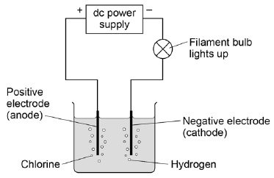
After passing an electric current through sodium chloride solution one product is sodium hydroxide (NaOH) solution.
The presence of sodium hydroxide can be shown by adding an indicator.
Name an indicator.
Give the colour of the indicator in sodium hydroxide solution.
Indicator __________________________________________________________
Colour ____________________________________________________________
(2)
(Total 8 marks)
Q3.
This question is about the periodic table.
In 1864 John Newlands suggested an arrangement of elements.
Figure 1 shows the arrangement Newlands suggested.
Figure 1
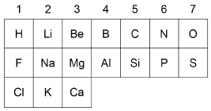
(a) Give two differences between column 1 in Figure 1 and Group 1 in the modern periodic table.
Use the periodic table to help you.
1. _________________________________________________________________
___________________________________________________________________
2. _________________________________________________________________
___________________________________________________________________
(2)
(b) In 1869 Mendeleev produced his periodic table.
Complete the sentence.
Choose the answer from the box.

insoluble | magnetic | undiscovered | unreactive
Mendeleev left gaps in his periodic table for elements that were
_________________________________________ .
(1)
(c) How are the elements ordered in the modern periodic table?
Tick one box.

Atomic mass
Atomic number
Melting point
Reactivity
(1)
Figure 2 shows part of the modern periodic table.
Figure 2
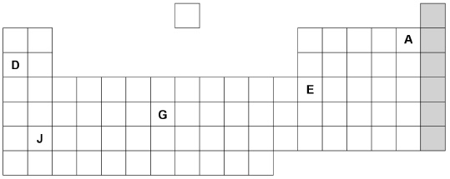
(d) Complete the sentences about the elements in Figure 2.
Choose the answers from the box.

A | D | E | G | J
Sodium is an alkali metal and is represented by the letter ____________________.
An element in group 3 is represented by the letter ____________________.
A gaseous non-metal element is represented by the letter ____________________.
(3)
(e) Figure 3 shows the electronic structure of an atom.
Figure 3
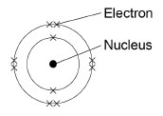
This element is in the shaded group on Figure 2.
Why is this element unreactive?
___________________________________________________________________
___________________________________________________________________
(1)
(f) Name the group of elements in the shaded column on Figure 2.
___________________________________________________________________
(1)
(Total 9 marks)
Q4.
Elements are made up of atoms.
(a) What is the approximate radius of an atom?
Tick one box.

1 × 10 m
1 × 10⁻¹ m
1 × 10⁻¹⁰ m
1 × 10⁻¹⁰⁰ m
(1)
(b) The figure below shows the atoms of five elements.
The letters are not the symbols of these elements.
Complete the sentence.
All of the elements in the figure above are in Group
_____________ of the periodic table.
(1)
(c) Which two atoms in the figure above are isotopes of the same element?
Explain your answer fully.
___________________________________________________________________
___________________________________________________________________
___________________________________________________________________
___________________________________________________________________
___________________________________________________________________
(3)
(d) The halogens are in Group 7 of the periodic table.
Explain the trend in reactivity of the halogens.
___________________________________________________________________
___________________________________________________________________
___________________________________________________________________
___________________________________________________________________
___________________________________________________________________
___________________________________________________________________
___________________________________________________________________
___________________________________________________________________
___________________________________________________________________
___________________________________________________________________
(6)
(Total 11 marks)

Mark schemes
Q1.
(a) carbon
1
(b) conduct electricity
1
(c) 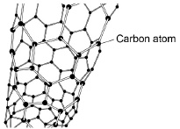
1
(d) carbon
hydrogen
either order
2
(e) a polymer
1
(f) slide
1
[7]
Q2.
(a) 3
1
(b) 5
1
(c) water
1
(d) opposite charges attract
1
(e) silver is less reactive than hydrogen
1
(f) oxygen
1
(g) universal indicator
allow other indicators
1
blue / purple
1
[8]
Q3.
(a) any two from:
• hydrogen is in group 1 on Newlands table
• fluorine / chlorine / halogens are in group 1 on Newlands table
• alkali metals are in group 2 on Newlands table
allow converse arguments relating to modern table
allow lithium / sodium / potassium for alkali metals
2
(b) undiscovered
1
(c) atomic number
1
(d) D
1
E
1
A
1
must be in this order
(e) has a complete outer shell of electrons
allow because has a stable arrangement of electrons
1
(f) noble gases
1
[9]
Q4.
(a) 1 × 10⁻¹⁰ m
1
(b) 1 / one
allow alkali metals
1
(c) R and S
1
because they have the same number of protons
allow same atomic number, different mass number
1
and a different numbers of neutrons
1
(d) Level 3 (5–6 marks):
A relevant and coherent explanation of the trend in reactivity. The response makes
logical links between the points raised and considers both the number of energy levels
and the distance between the nucleus and the outer energy level.
Level 2 (3–4 marks):
Statements that are linked to provide a simple explanation of the trend in reactivity using either the number of energy levels or the distance between the nucleus and the outer energy level.
Level 1 (1–2 marks):
Simple statements made about the halogens or the trend in reactivity.
0 marks:
No relevant comment
Indicative content
Simple statements / descriptions
• have 7 electrons in the outer shell
• need to gain an electron
• form ions with a -1 charge
• halogens further down the group are less reactive (or vice versa)
• halogens further down the group have more shells or energy levels (or vice versa)
Linked statements / explanations
• have 7 electrons in the outer shell so need to gain an electron to have the electronic structure of a noble gas
• halogens further down the group are less reactive because they have more shells or energy levels (or vice versa)
• halogens further down the group have more shells or energy levels so less attractive force on the incoming electron (or vice versa)
• halogens further down the group have more shells or energy levels so more ‘shielding’ against the incoming electron (or vice versa)
• outer electrons of halogens further down group are further away from the attractive force of the nucleus (or vice versa)
• an electron is less easily gained because there are more shells or energy
levels (or vice versa)
• an electron is less easily gained because the outer electrons are further from
the attractive force of the nucleus (or vice versa)
6
[11]

